URL:

<https://www.youtube.com/watch?v=OKYJCHHSWb4&list=PLdpzxOOAlwvLNOxX0RfndiYSt1Le9azze&index=20>

**Example - Prepress:**  
I intentionally created some snapshots as a backup. Later, I deleted the associated EBS volumes and the EC2 instance. However, I retained the snapshots for backup purposes.

**Demonstration Objective:**  
Today, we will demonstrate two scenarios where snapshots may be deleted:

1. Snapshots that are not attached to any volume.
2. Snapshots that are attached to a volume, but the volume itself is not attached to any EC2 instance.

In both cases, we will observe how AWS handles such orphaned or unused snapshots.

🡺We need to create one instance

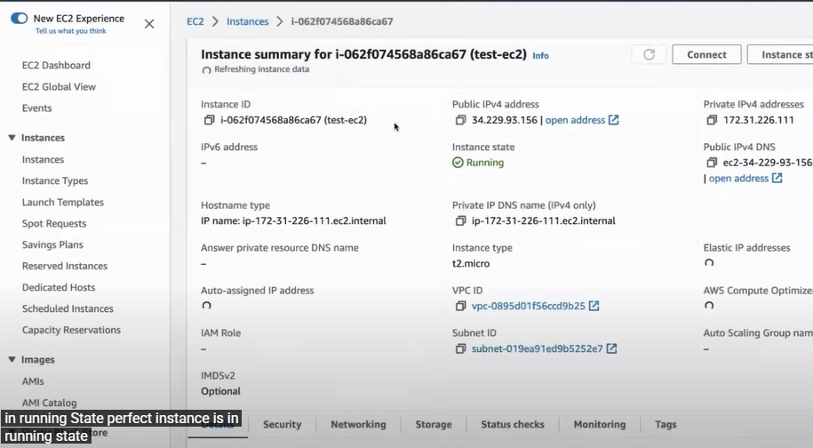

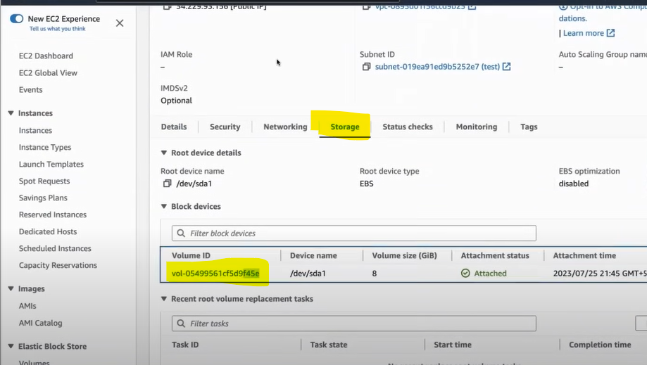

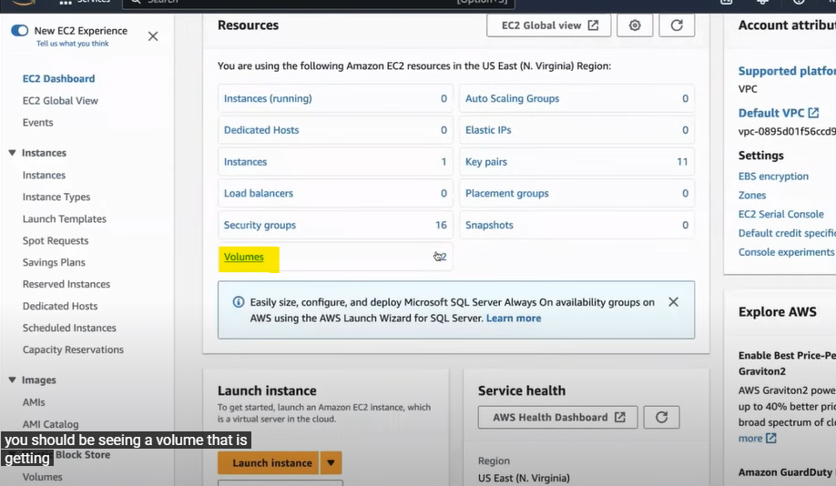

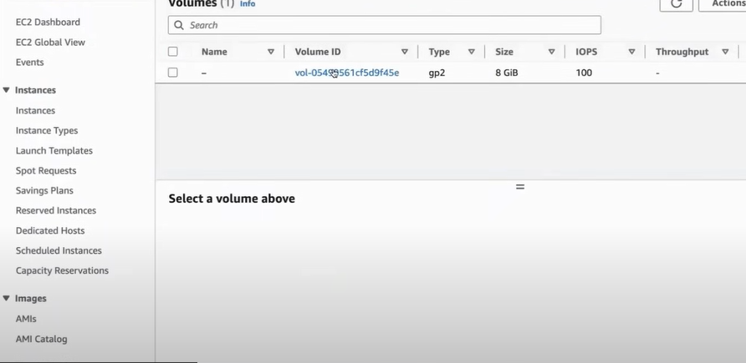

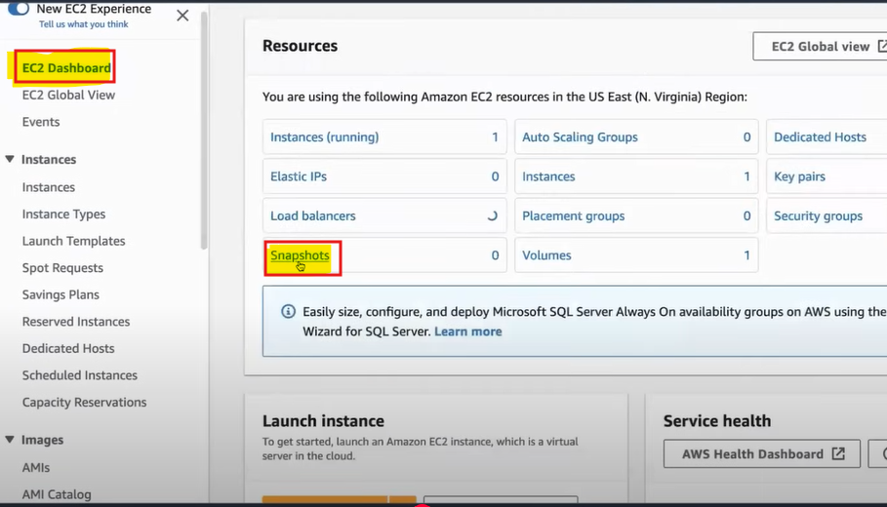

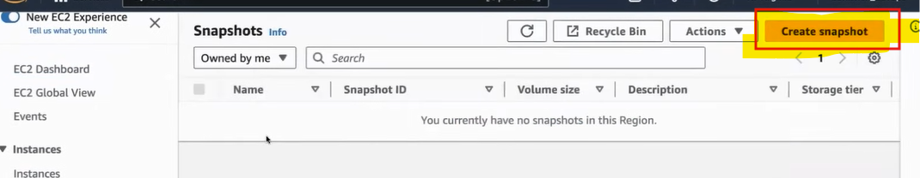

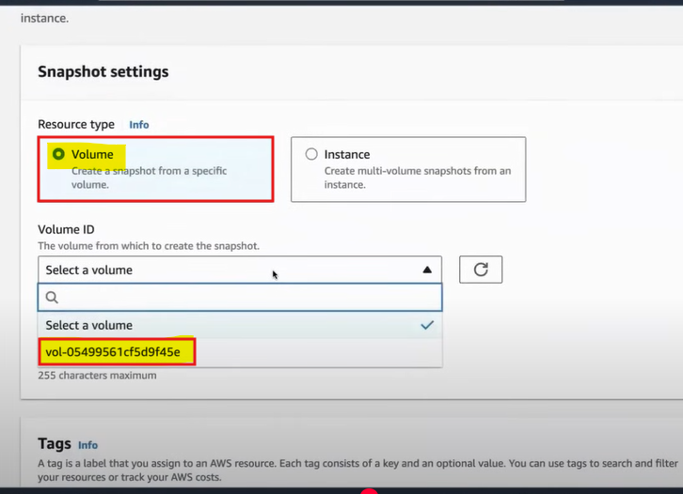

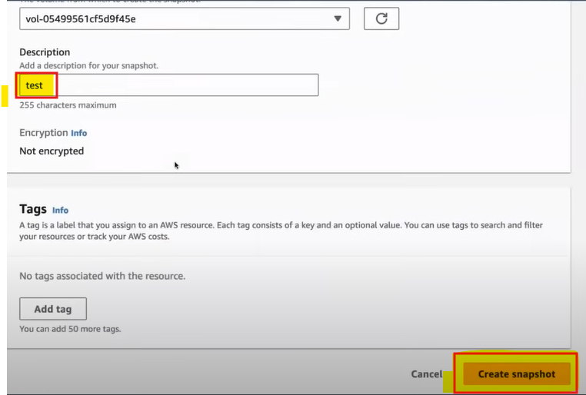

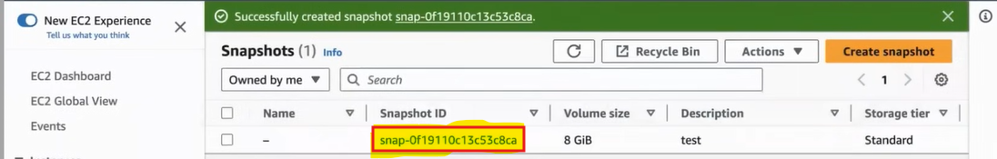

**Sometimes, a user may delete an EC2 instance and its associated volume but forget to delete the corresponding EBS snapshots. In such cases, the snapshots remain in the account and continue to incur storage costs.**

**For example,** the user might have hundreds of snapshots and may not realize they are still being retained.

When an EC2 instance is deleted, the attached volume may be deleted automatically, but the snapshots remain unless manually removed. To handle this, we use a Lambda function that identifies and deletes **stale snapshots**.

This Lambda function **does not delete snapshots** that:

* Are associated with a volume, and
* That volume is still attached to an EC2 instance (either running or stopped).

It only deletes snapshots that are truly stale—those not tied to any volume, or tied to volumes not attached to any EC2 instance—thereby helping in cost optimization without affecting live infrastructure.

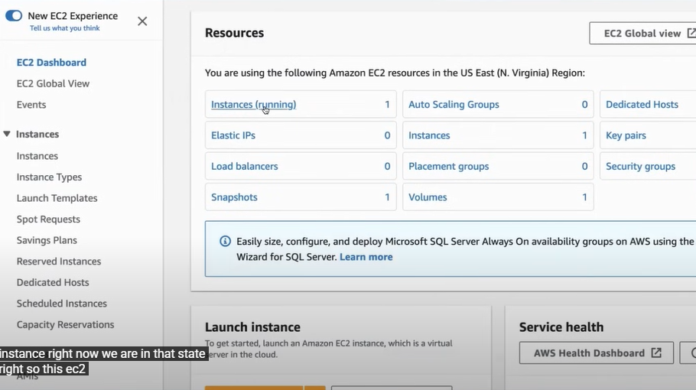

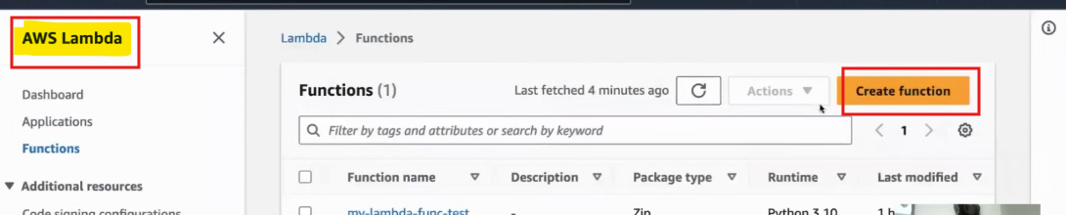

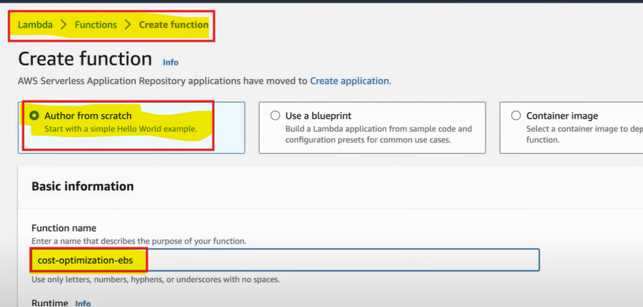

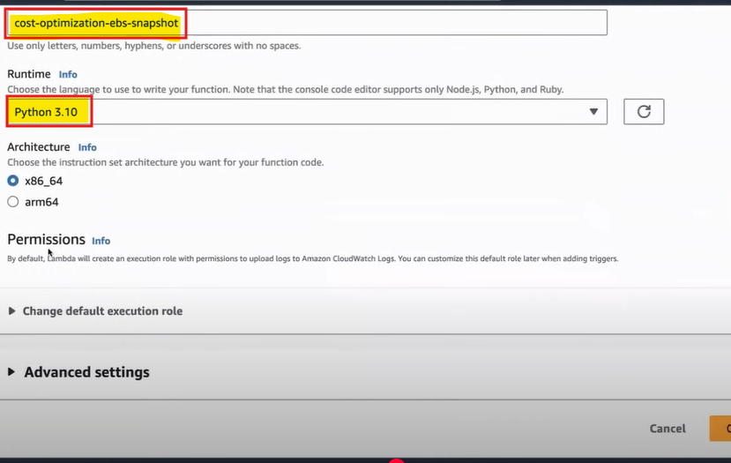

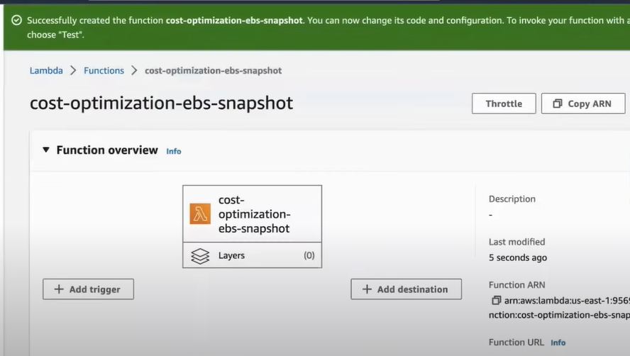

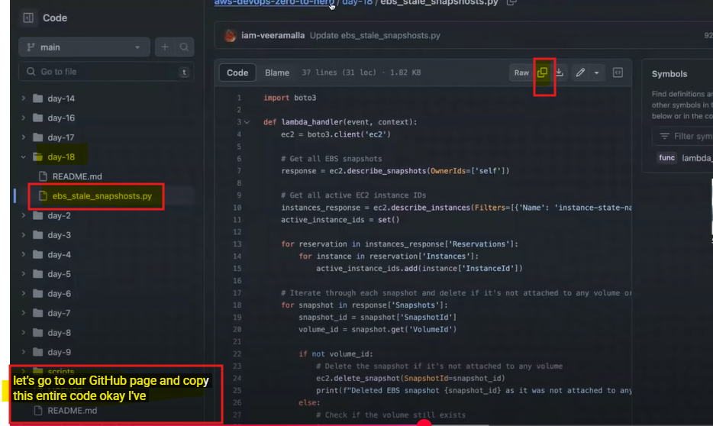

🡺 **Remove the below code and Copy the above github code**

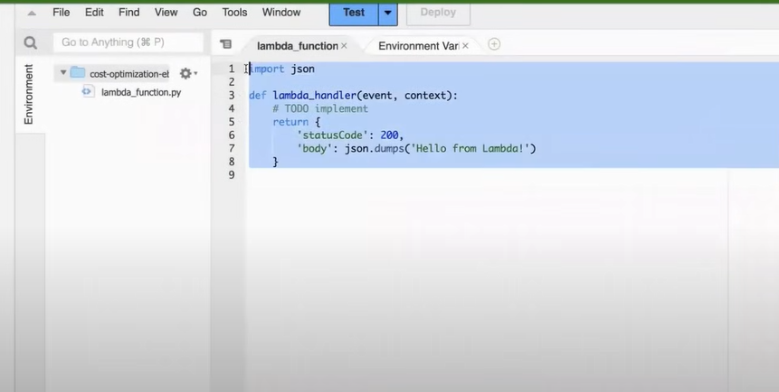

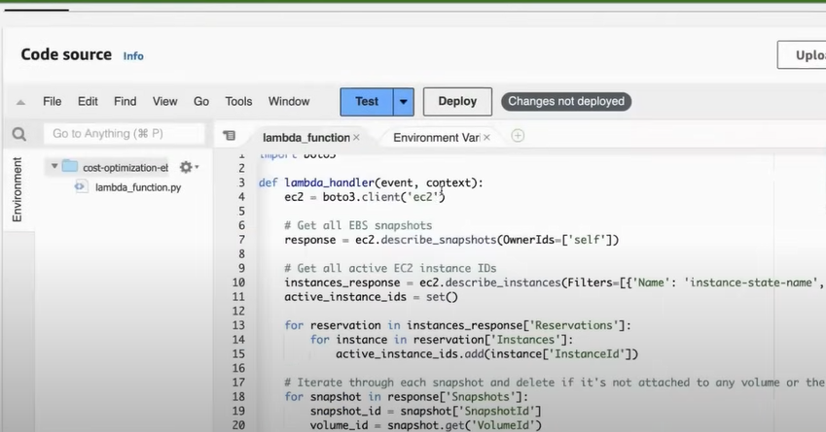

🡺**After copying the code we need to save this and click “deploy””**

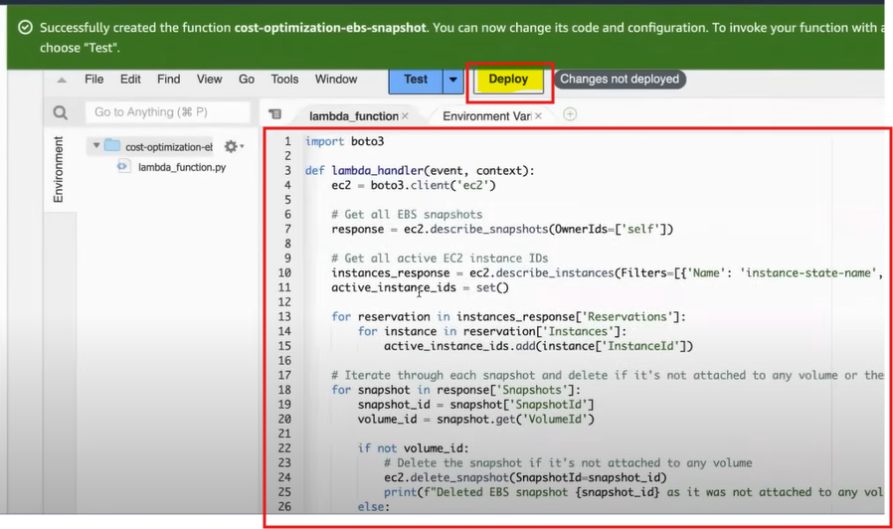

🡺 **After deploying we need to save the code and click “Test”**

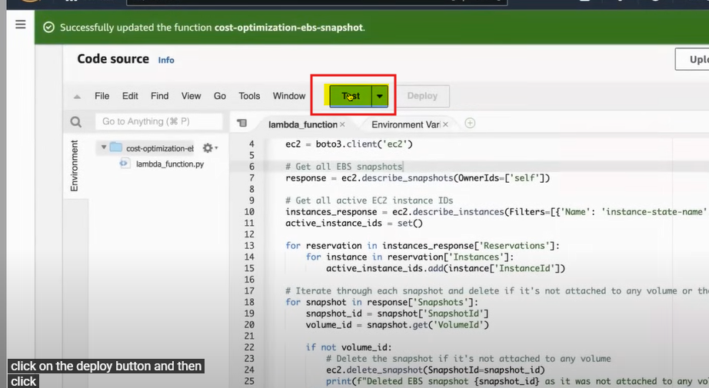

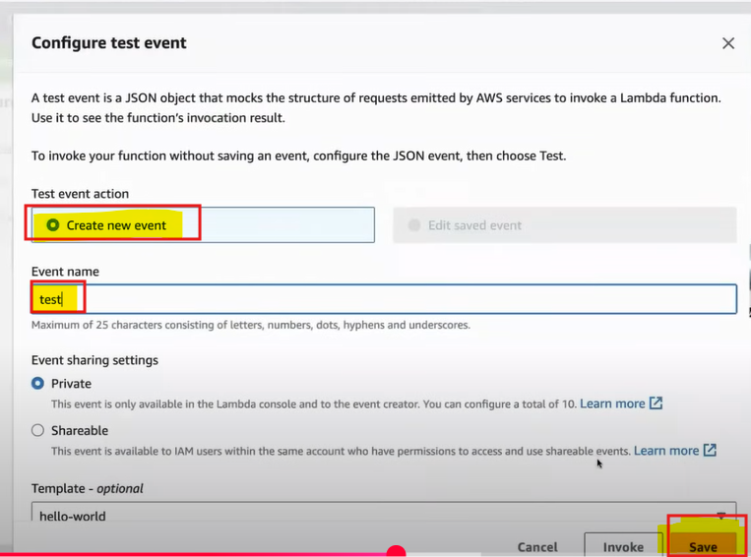

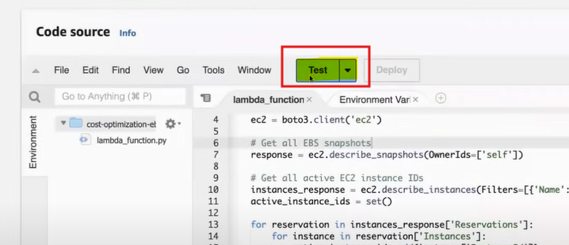

🡺It failed some

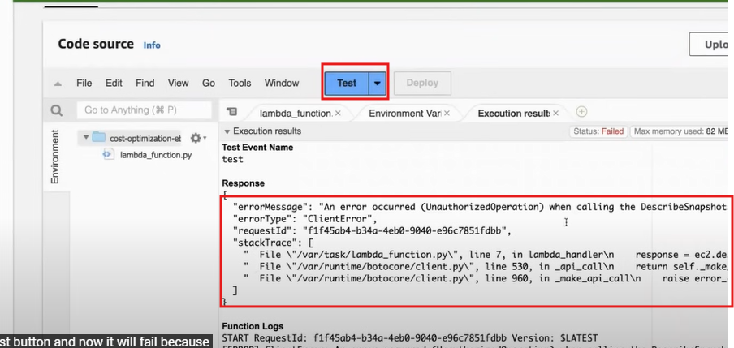

🡺 **By default Lambda function execution is only**

**"3-Section" and it is also falling for some permissions issue**

**Error – It showing that the described snapshots permission or that role which is running this easy to Lambda furcation does not have permissions to describe the snapshots**

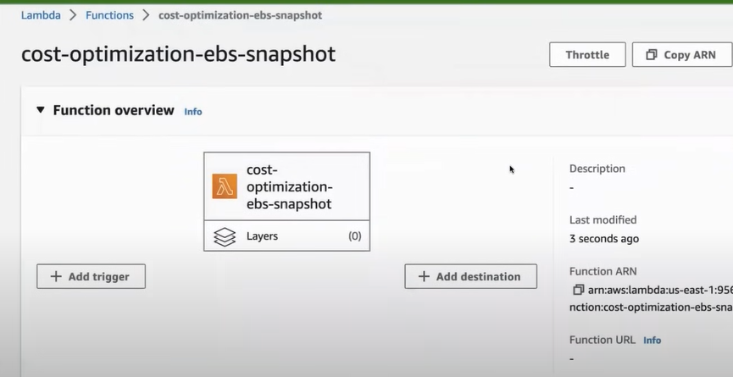

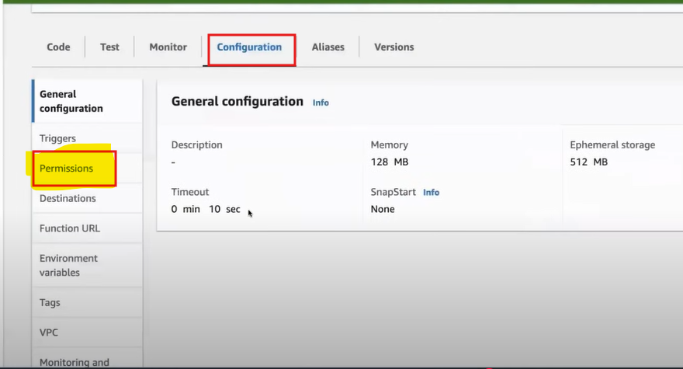

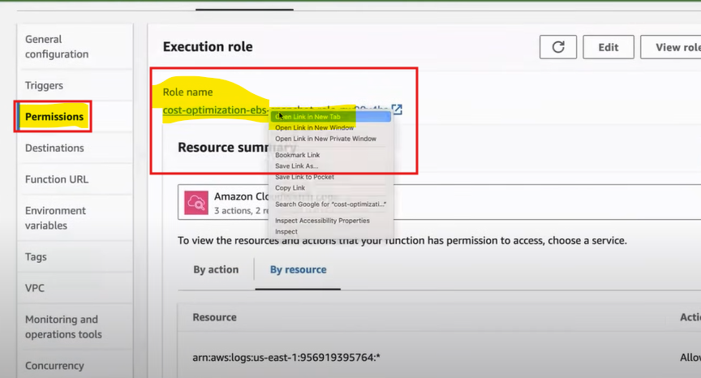

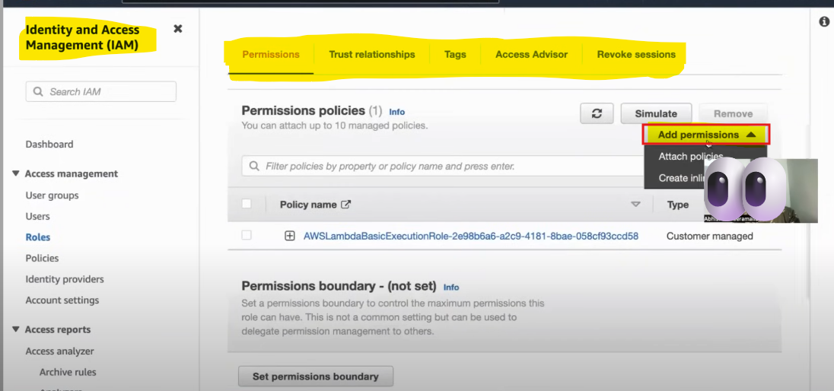

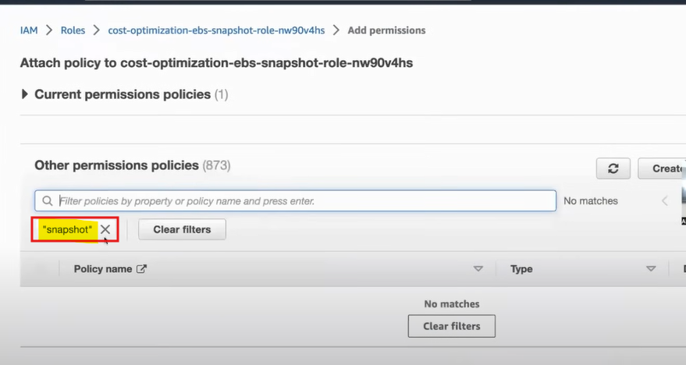

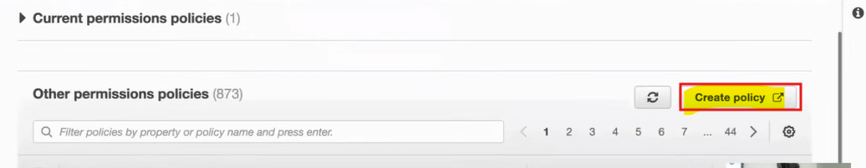

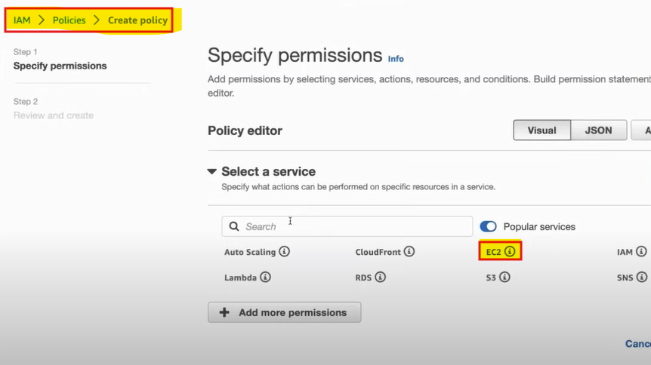

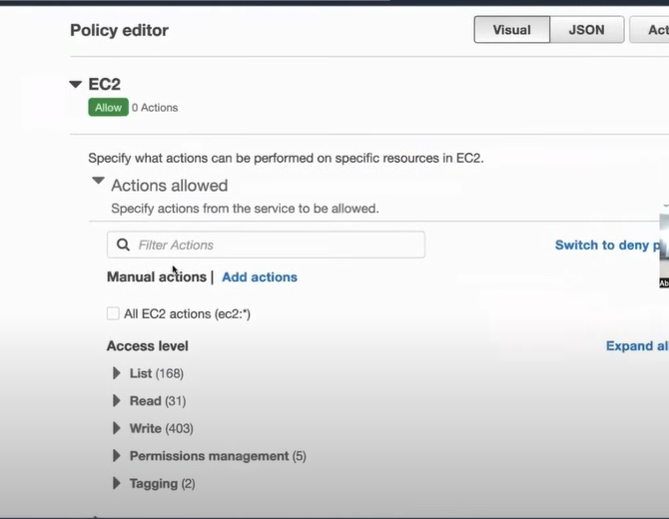

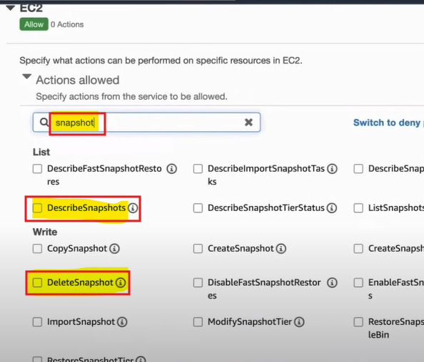

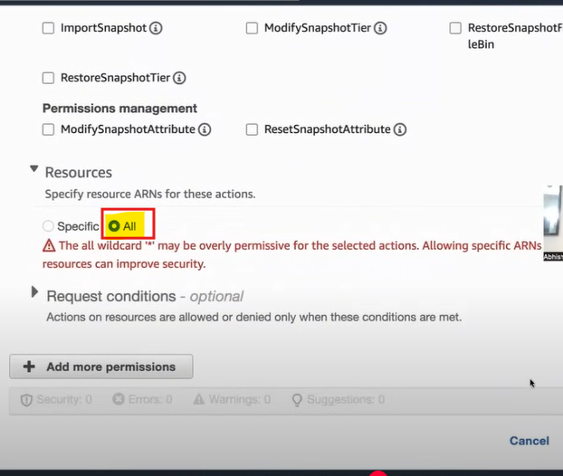

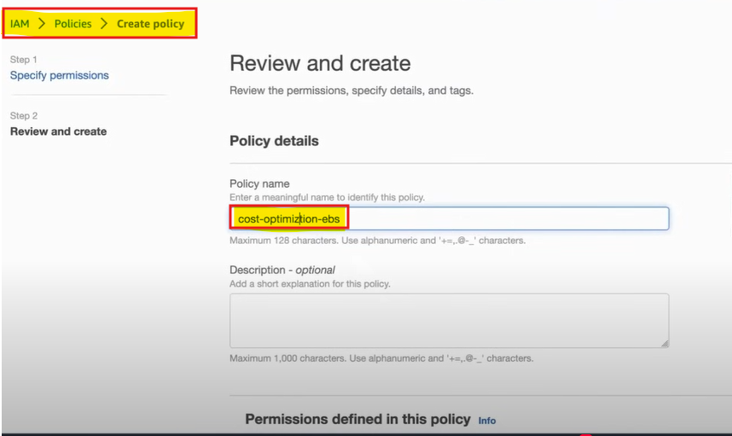

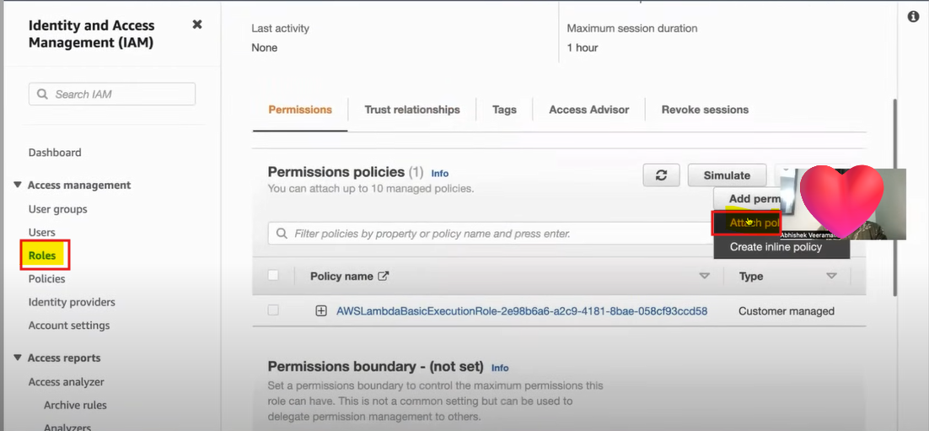

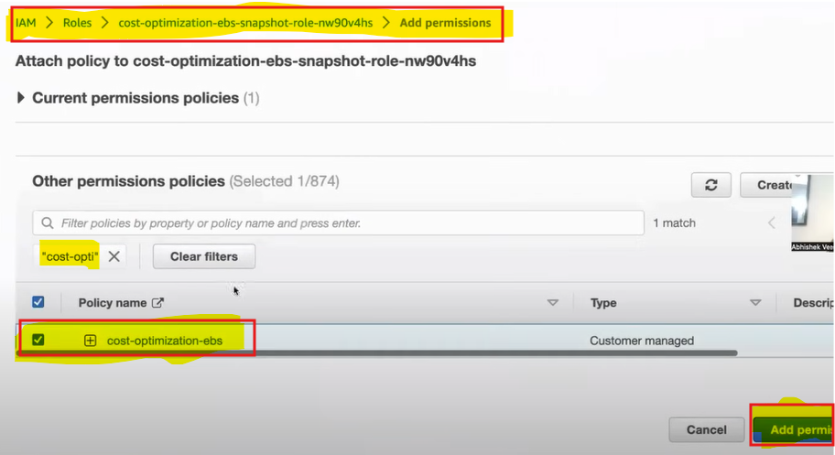

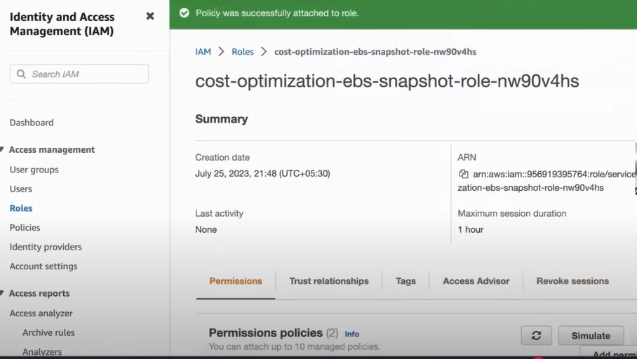

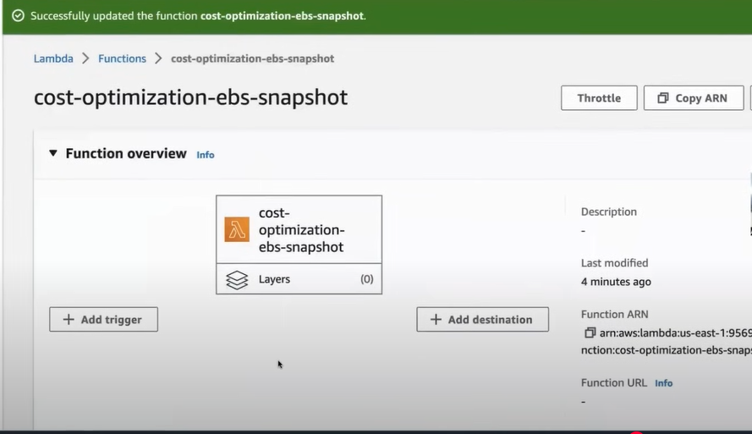

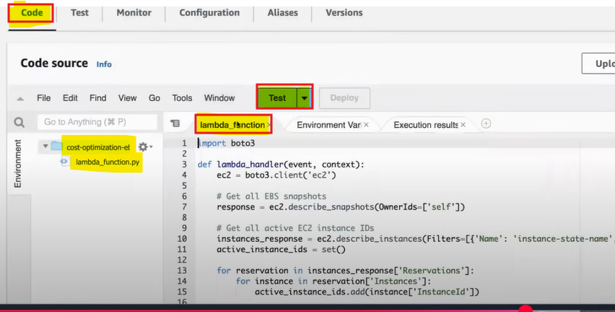

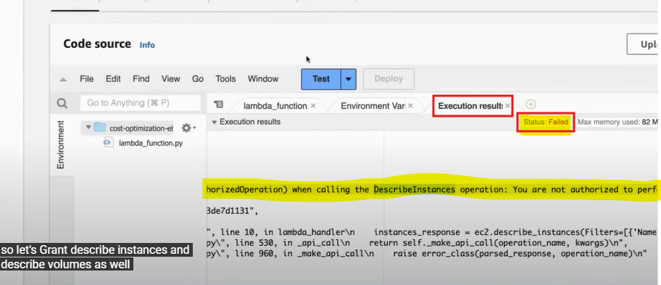

🡺 **Again, we can give permission like "Describe Volume and Describe instance" for grant the Permissions**

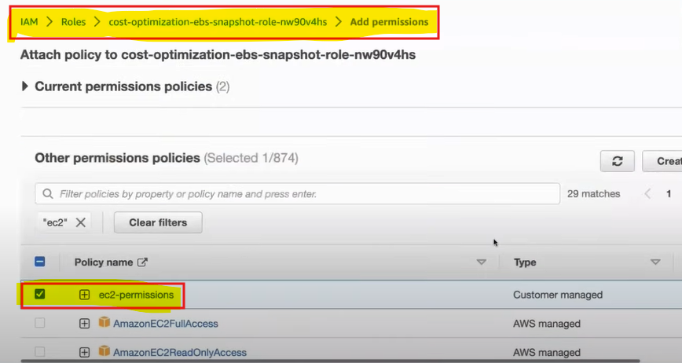

🡺**Now the script got executed for grant the permission but we will notice that the snapshot is not deleted**

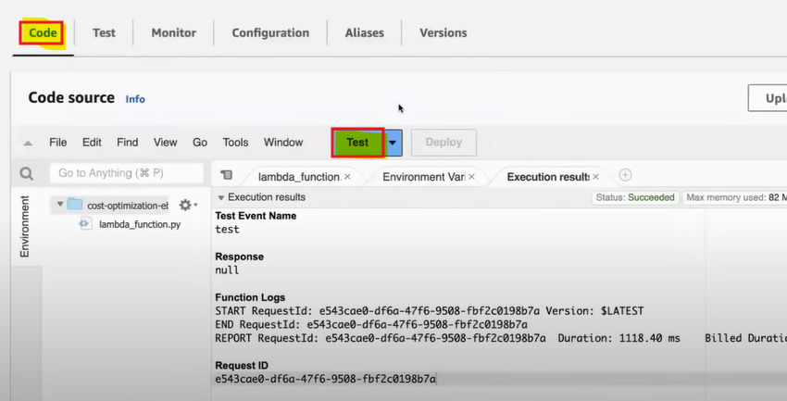

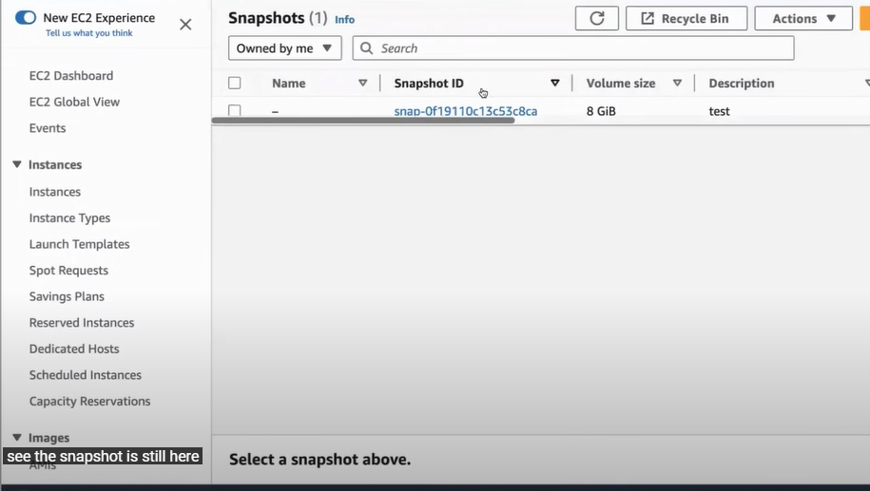

**🡺Now we Deleted the EC2 instance that instance will deleted the volume as well.**

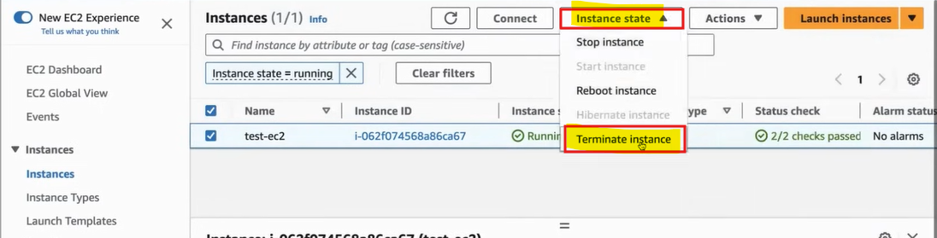

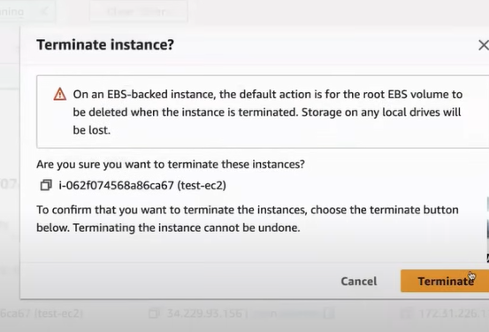

**🡺Once we terminate the instance or instance shutting down as soon as the instance will go down the volume will also delete**

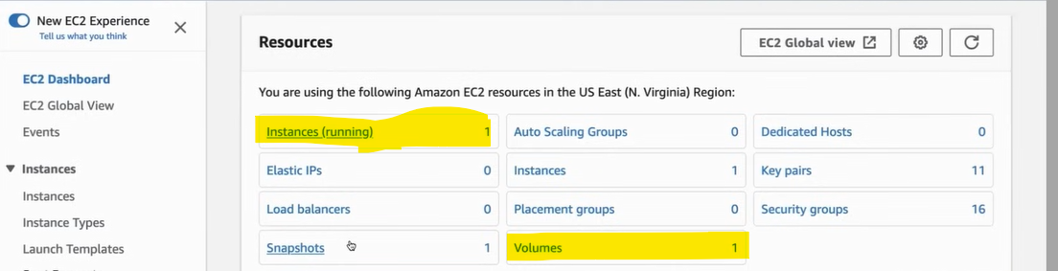

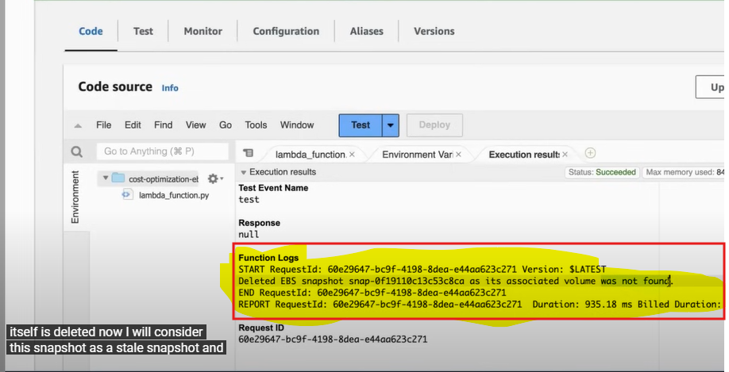

**🡺Snapshot is still there , we write one if condition like the timestamp and if the snapshot was used 30 days we will deleted**

